LinkedIn

**Product Dissection for LinkedIn**

**Company Overview:**

LinkedIn was founded in 2002 by Reid Hoffman, Allen Blue, Konstantin Guericke, Eric Ly, and Jean-Luc Vaillant. LinkedIn is a professional networking platform where professionals can connect with colleagues, build their professional network, and showcase their skills and experience. It offers features like creating a professional profile, connecting with other professionals, joining industry-specific groups, and searching for job opportunities. LinkedIn is widely used for career development, networking, and professional growth. It provides a platform for professionals to share knowledge, insights, and industry updates. It is a valuable resource for job seekers, recruiters, and businesses looking to connect with professionals in various fields.

### **Product Dissection and Real-World Problems Solved by LinkedIn:**

LinkedIn, a global social media phenomenon, has effectively addressed real-world challenges through its innovative product offerings. With a focus on visual storytelling, linkedin empowers users to authentically share their experiences and passions, bridging the gap between digital interactions and genuine connections. By allowing users to share photos and videos accompanied by captions, locations, and hashtags, LinkedIn provides a solution to the need for meaningful expression and engagement. This core feature solves the problem of connecting in an increasingly digital world, enabling users to form genuine relationships and engage in conversations that transcend geographical boundaries.

LinkedIn's ingenious engagement features, such as likes, comments, and personalized content recommendations through the "Explore" feature, have revolutionized how users interact with content. By addressing the challenge of content overload, LinkedIn curates relevant content, helping users discover new accounts, posts, and trends tailored to their interests. Furthermore, LinkedIn's introduction of hashtags has transformed content discovery by allowing users to categorize their posts with keywords. This innovative approach effectively addresses the challenge of navigating through a sea of content to find relevant information, making it easier for users to connect with content aligned with their interests and engage in conversations that matter to them.

In conclusion, LinkedIn's product design has successfully tackled real-world problems by creating a platform that nurtures creativity, fosters connections, and offers a space for self-expression. Through its diverse features, LinkedIn addresses the need for authentic engagement, content curation, and meaningful discovery, shaping the digital landscape and providing practical solutions to the evolving needs of its global user base.

### **Case Study: Real-World Problems and LinkedIn's Innovative Solutions**

LinkedIn, a leading social media platform, has not only revolutionized the way we share and consume content but has also addressed significant real-world challenges through its innovative features. By identifying user needs and leveraging technology, IinkedIn has positioned itself as a solution-driven platform that fosters connections, encourages self-expression, and enhances digital interactions.

**Problem 1: Increasing User Engagement**

**Real-World Challenge :** LinkedIn noticed a decline in user engagement, with many users passively browsing their feed without actively participating in discussions or posting updates.

**LinkedIn’s Solution :**

LinkedIn introduced the "Creator Mode," which allows users to highlight their expertise by adding tags to their profiles and content. This encourages users to share more content, engage in conversations, and establish themselves as thought leaders in their industries.

**Problem 2: Inaccurate Job Recommendations**

**Real-World Challenges :** Users were often receiving job recommendations that were not relevant to their skills or career goals, leading to frustration.

**LinkedIn’s Solution :**

LinkedIn leveraged machine learning and AI algorithms to improve job recommendation accuracy. They incorporated user feedback and behavior data to fine-tune the recommendations, resulting in more tailored job suggestions for users.

**Problem 3: Encouraging Diverse Hiring**

**Real-World Challenge :** Many organizations struggled to diversify their workforce, and LinkedIn wanted to play a role in addressing this issue.

**LinkedIn’s Solution :**

LinkedIn introduced a feature that allows companies to anonymize applicant profiles during the initial stages of the hiring process. This helps reduce bias in hiring decisions by focusing on skills and qualifications rather than personal information, leading to more inclusive hiring practices.

**Problem 4: Spam and Inauthentic Profiles**

**Real-World Challenges :** LinkedIn faced an increasing number of fake profiles and spam content, which undermined the platform's credibility.

**LinkedIn’s Solution :**

LinkedIn implemented stricter verification processes for new profiles, including phone number verification and AI-based profile analysis to detect suspicious behavior. They also encouraged users to report suspicious accounts, helping maintain the platform's authenticity and trustworthiness.

These innovative solutions showcase how LinkedIn has addressed real-world challenges to enhance user experience, improve diversity and inclusion, and maintain the integrity of their platform.

**Conclusion:**

LinkedIn has addressed various challenges that users encounter in the digital landscape. This case study showcases how linkedIn’s user-centric approach and continuous innovation have positioned it as a leader in the social media domain, effectively shaping the way we engage and interact online.By fostering genuine connections, curating content, supporting creativity, and enabling personal branding, linkedIn has addressed various challenges that users encounter in the digital world.The integration of new features, often driven by user feedback, reflects LinkedIn's dedication to enhancing user experience, supporting professional growth, and maintaining a valuable platform for networking, job searching, and skill development.

### 

### **Top Features of LinkedIn:**

**1.Profile Creation:**Users can create detailed professional profiles, including information about their education, work experience, skills, and accomplishments.

**2.Connections and Networking:**LinkedIn allows users to connect with professionals in their industry, colleagues, classmates, and other contacts to build a professional network.

**3.Job Search and Postings:**Job seekers can search for job opportunities based on various criteria, and companies can post job openings to reach a broad audience of potential candidates.

**4.Content Sharing:**Users can share updates, articles, and multimedia content to showcase their expertise, stay informed about industry trends, and engage with their network.

**5.LinkedIn Learning:**LinkedIn offers a learning platform with a wide range of courses and tutorials covering various professional skills and topics.

**6.Groups:**LinkedIn Groups enable users to join communities related to their industry or interests, fostering discussions, networking, and knowledge sharing.

### **Schema Description:**

The schema for LinkedIn involves multiple entities that represent different aspects of the platform. These entities include Users, Posts, Comments, Likes, Followers, Hashtags, and more. Each entity has specific attributes that describe its properties and relationships with other entities.

**User Entity-**

**UserID:** A unique identifier for each user.

**FirstName and LastName**: The user's first and last names.

**Email**: User's email address.

**Password**: Encrypted password for account security.

**ProfilePictureURL**: URL to the user's profile picture.

**DateOfBirth:** User's date of birth.

**Location:** User's current location.

**ContactInformation**: Phone numbers, addresses, etc.

**Profile Entity -**

**ProfileID:** Unique identifier for each profile.

**UserID:** Foreign key linking to the User entity.

**EducationDetails**: Information about the user's educational background.

**WorkExperience:** Details about the user's work history.

**Skills:** A list of skills associated with the user.

Recommendations: Recommendations given and received.

**Connection Entity -**

**ConnectionID**: Unique identifier for each connection.

**UserID:** Foreign keys linking to the User entity.

**ConnectionStrength:** Strength or type of connection (e.g., colleague, friend).

**ConnectionDate:** Timestamp indicating when the connection was established.

**Post Entity -**

**PostID:** Unique identifier for each post.

**UserID:** Foreign key linking to the User entity.

**Content:** Text content of the post.

**MediaAttachments:** Links or references to attached media.

**Timestamp:** Time when the post was created.

**Caption**: Text accompanying the post, providing context

**Message Entity -**

**MessageID:** Unique identifier for each message.

**SenderID and ReceiverID**: Foreign keys linking to the User entity.

**Content**: Text content of the message.

**Timestamp:** Time when the message was sent.

**Like Entity:**

Likes represent user appreciation for posts:

**LikeID (Primary Key):** A unique identifier for each like.

**PostID (Foreign Key referencing Post Entity):** The post being liked.

**UserID (Foreign Key referencing User Entity):** The user who liked the post.

**Like_Date:** The date when the like was registered.

**Hashtag Table:**

**hashtag_id (Primary Key):** Unique identifier for each hashtag.

**hashtag_text:** The actual text of the hashtag (e.g., #DataScience).

**usage_count**: Number of times the hashtag has been used.

**first_used_date:** Timestamp indicating when the hashtag was first used.

**last_used_date:** Timestamp indicating when the hashtag was most recently used.

**Relationships are:**

**1. Connections:** You can connect with other professionals in your industry, which allows you to see their updates, engage with their content, and message them directly.

**2. Endorsements and Recommendations:** You can endorse skills and write recommendations for your connections to enhance their profiles and build stronger relationships.

**3. Messaging:** LinkedIn's messaging feature allows you to have real-time conversations with your connections. You can also send attachments and create group messages.

**4. Follow and Connect Buttons:** On LinkedIn profiles and company pages, you can use the "Follow" or "Connect" buttons to initiate and build connections with professionals or companies.

**5. Search Filters:** Use LinkedIn's advanced search filters to find specific individuals or companies based on criteria such as location, industry, job title, and more.

**6. LinkedIn Events:** You can create and participate in LinkedIn Events to connect with professionals who share your interests or are attending the same virtual or in-person events.

**7. Content Sharing:** Posting and sharing valuable content, such as articles and updates, can help you engage with your network and strengthen relationships by showcasing your expertise.

**ER Diagram:**

Let's construct an ER diagram that vividly portrays the relationships and attributes of the entities within the LinkedIn schema. This ER diagram will serve as a visual representation, shedding light on the pivotal components of LinkedIn data model. By employing this diagram, you'll gain a clearer grasp of the intricate interactions and connections that define the platform's dynamics.

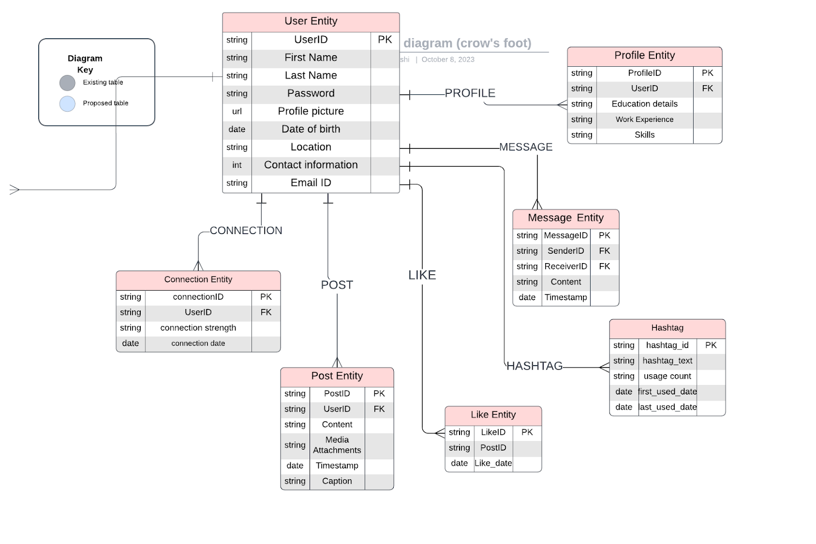

### **Conclusion**

In this case study, we delved into the design of LinkedIn's schema and Entity-Relationship diagram. LinkedIn has revolutionized the way people share and engage with visual content, fostering connections and creative expression. The platform's intricate data model, consisting of entities like users, posts, comments, likes, followers, hashtags, and associations, forms the foundation for its seamless functionality. By understanding this schema, we gain sight into how LinkedIn effectively manages the complexities of user interactions and content sharing, contributing to its widespread popularity and continued growth in the world of social media.